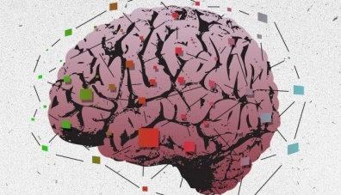**GROWTH MINDSET**

**Part 1: BRAIN & LEARNING**

Many of you have heard phrases like “Work harder”, “Try again,” from your teachers and parents when you failed to do something. Boring, isn’t it? What if we tell you that there is a scientific explanation? Your brain *can* get stronger and smarter with each try and new opportunity. Here is how:

<http://safeshare.tv/w/JxLqkgLznP>

**TASK 1-** Answer these questions about the video you have just watched:

* How do people become more intelligent? How does the diagram of the neurons “At birth vs. at age 6” demonstrate this?
* How does the second diagram of the nerves of the animal living in a cage vs. an animal living with other animals and toys demonstrate this?
* How are our brains like muscles? Explain.
* When do our brains grow the most?

Let’s watch another video that explains how the brain can be *rewired* as we learn and think differently:

<http://safeshare.tv/w/LDYhlyYfnG>

**TASK 2-** What is neuroplasticity? Explain.

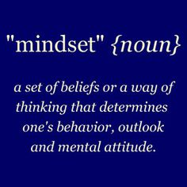After neuroscientists found out that the brain is flexible, a new trend in education emerged: **Growth Mindset.** The growth mindset is based on the belief that people can change their intelligence or ability through hard work, practice, effort, and using the right strategies. Therefore, it is important for students to understand that the ability to learn is a skill that continues to grow over time.

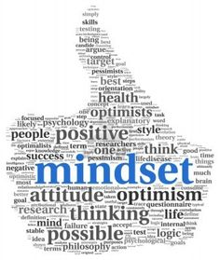Students with a growth mindset believe that intelligence can be developed. These students see effort as the key to success. They believe that ability can change as a result of effort, **perseverance**, and practice. They are more interested in learning, more eager to take on **challenges**, and more academically successful. They:

* Ask more questions.
* Seek out challenges that allow them to learn something new.
* Spend more time on difficult schoolwork.
* Try new strategies.
* Seek help from other students or the teachers.
* See mistakes as ways to learn and grow; so, they aren’t afraid of making mistakes. They realize that mistakes are a part of the learning process.

Here is a video about a famous person with a growth mindset: <http://safeshare.tv/w/WkGefwSGtF>

Students with a **fixed mindset**, on the other hand, believe that people are born with a certain amount of intelligence, and they can’t do much to change that. For example, they might say “I just can’t learn math.” These students typically worry about not looking smart, get upset by mistakes, and give up sooner on difficult tasks. When they are faced with a challenge, they give up easily.

Growth mindset is not only about getting higher scores on tests and building better study habits. Having a growth mindset can give you the confidence you need to progress in other activities that the brain is involved in like sports, the arts, or social interactions. Do you want to try it? Here is a recipe for you:

**MINDSETS CAN CHANGE!**

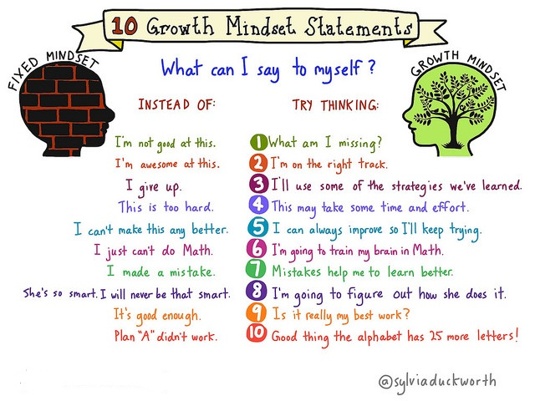

**TASK 3-** Add two more examples to the list above. Write your examples in the box provided below:



**PART 2- SUCCESS, FAILURE & RESILIENCE**

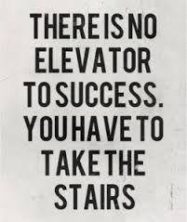Every single day we see successful people around us. They seem to be so happy, they often smile, and they obviously enjoy life. Most people think of them as the ‘lucky ones’. Well, often in life things are not what they seem to be. What you see about most of these people is just the top of the iceberg. Most of the successful ones went through years of [struggle](http://businessideaslab.com/learn-to-love-to-struggle/) and **sacrifice**. All of them know what hard work and **dedication** is and most of them have had many moments of **disappointment** and failure. This is how they finally made it and this story is a common one for almost all of them as shown in the image below.

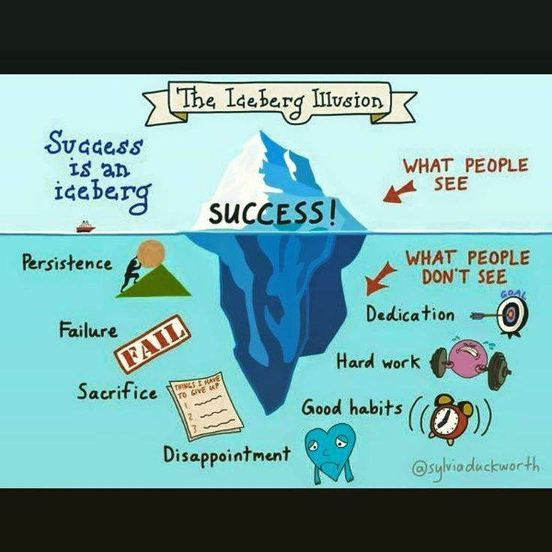

Do you want to see some examples? Here is a video about famous failures:

<http://safeshare.tv/w/jvPiBQRzDw>

What is common about all these people? They didn’t give up even though they had failed many times. Instead, they chose to learn from their mistakes. They didn’t let failure be an ending; they made it a beginning. In other words, they failed well. What does to ***fail well*** mean?

* They reflected on what happened and listed all the facts.

* They took responsibility for their own actions. 



* They thought about what worked/didn’t work.



* They planned what to do differently next time.



* They took action to give it another try.



* They repeated this process until they succeeded.

As you can see from the cycle above, failure is not the opposite of success. It is part of success; so, don’t be afraid of failure. It shows you exactly what you don’t know and it is a great way what to know what is next. It actually takes quite a bit of work to fail well. All of the twists and turns and bumps and gaps along the way point to **resilience, which is a very important trait on the way to success.** Not giving up, looking for new solutions, believing in yourself, pushing yourself beyond what you think you know… These are all characteristics of resilience that can be summed up in this humorous clip☺

<http://safeshare.tv/w/kYgqyZVCmA>

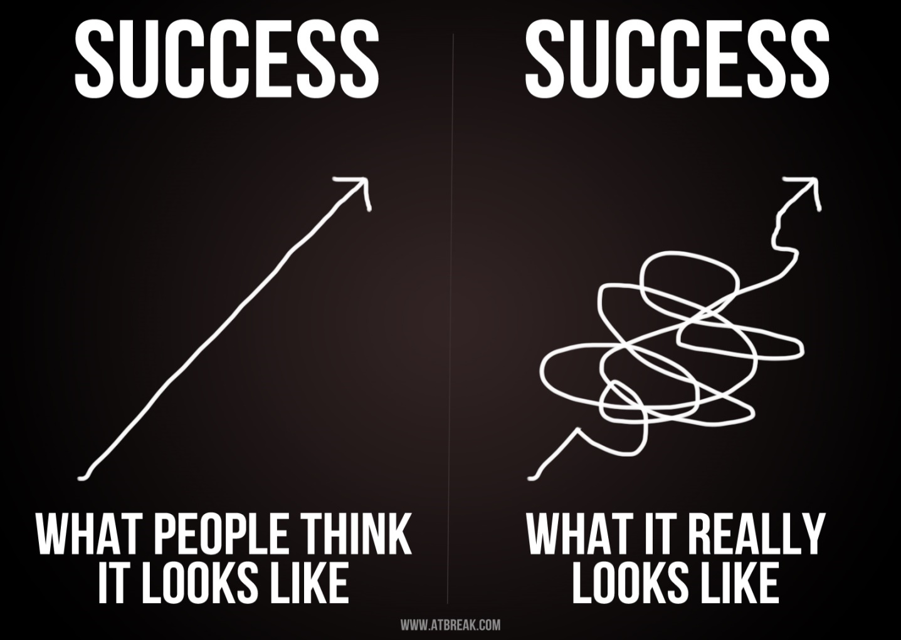

**TASK 4-** **JOURNAL ENTRY:** As part of our ‘Growth Mindset’ class, write a journal entry about a success story. Think about a time when you were successful at something and explain your journey to success.

Did you just wake up and be a brilliant skier? A pro tennis player? An amazing artist? A super reader?

What did the journey look like? How did you get there?

Finally, draw your own version of success in the space provided below.



Today, many people believe that even though mindsets are powerful beliefs, they are just something in your mind and you can choose to change them. In other words, it is up to you to choose whether you let failure **defeat** or i**nspire** you. Let’s watch our last video about it: You Can Learn Anything!

<http://safeshare.tv/w/dqsLsYqbmy>

**TASK 5- BLOG POST**: Write a blog post explaining whether you agree with the ideas on growth mindset or not by giving examples from your own life. What can you do to embrace the growth mindset and quit your habits related to a fixed mindset?

